**Android Applications Development**

**Proposal**

**Title**: Vehicle service Booking

**Coventry ID**: 10250048

**Name**: Anush Gajurel

1. Aims:

* To provide vehicle service as per customer needs and demands.
* To saves user time.
* To make application more user friendly.

1. Objectives:

* To provide vehicle service as per customer needs and demands.
* To save user time.
* To make application more user friendly.

1. Features:

* User can login and register.
* Feedback system.
* Admin cam add, update, and delete the product.
* User can book the service center and book the date and time as well as payment system.

1. Prototypes of the features:

* The prototype of the features is as shown below:

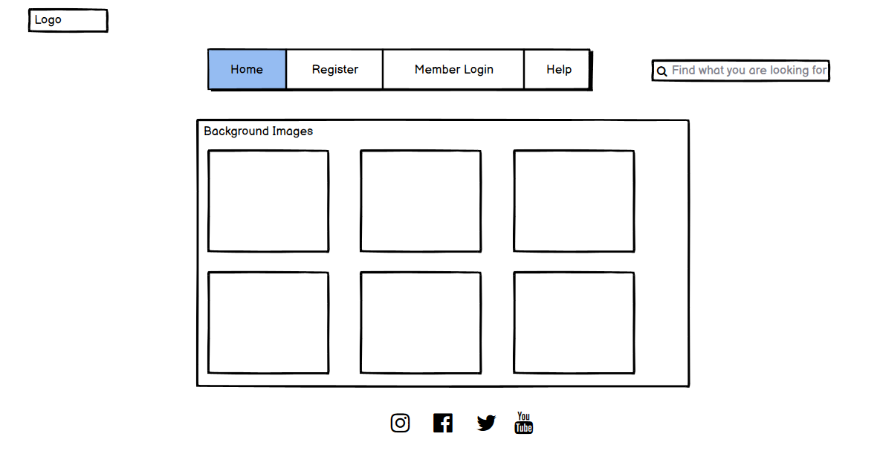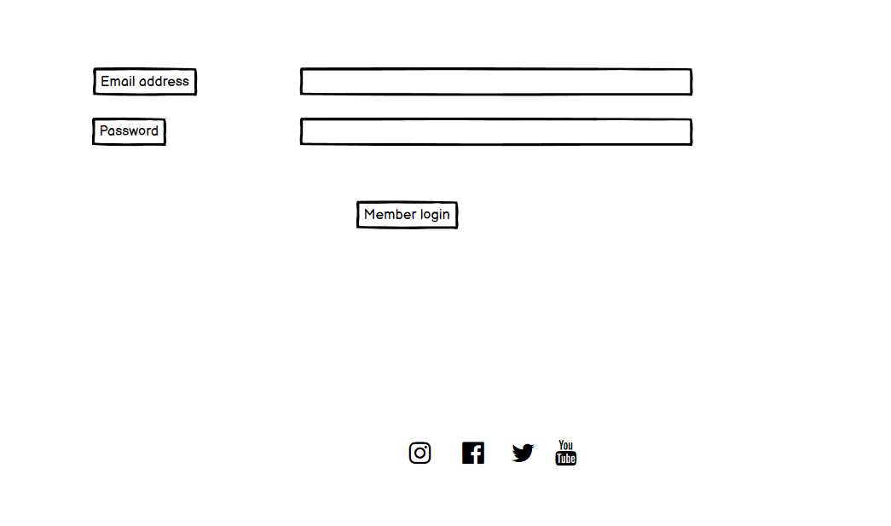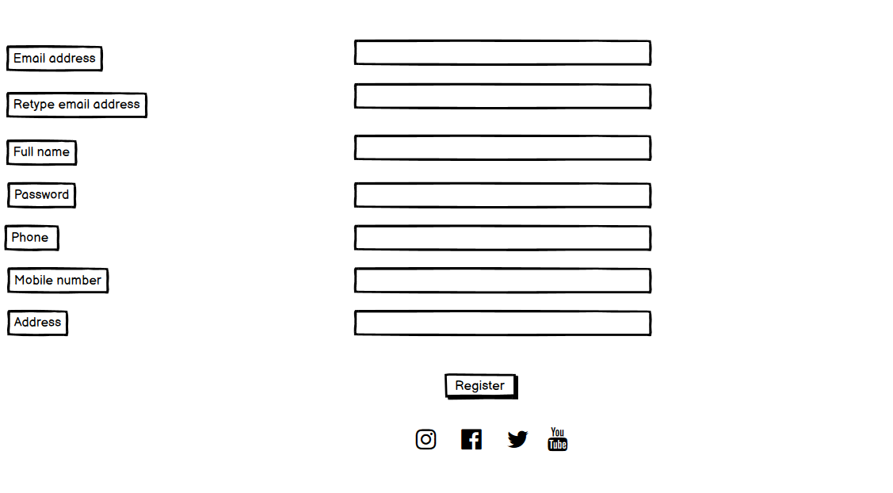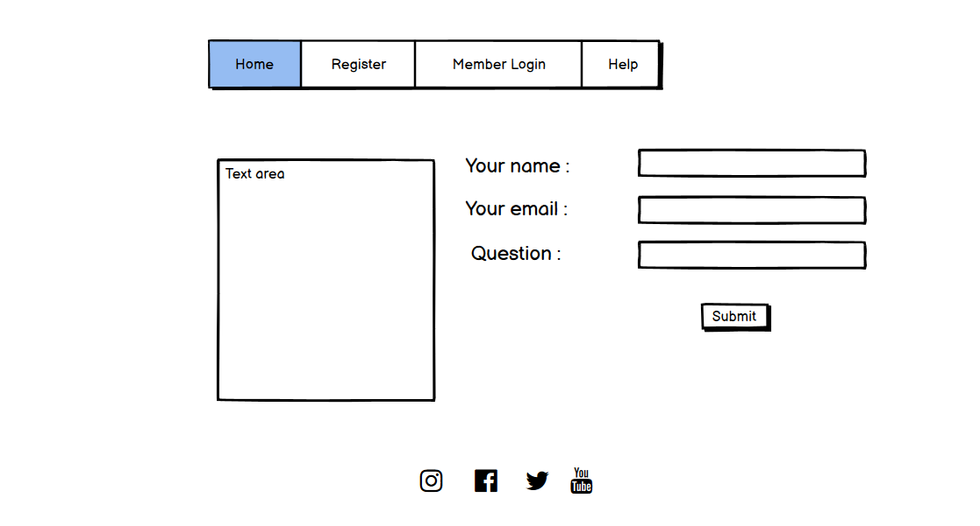

1. Project GitHub Classroom Link